

Requirement List

By Sajib das

내용

Requirement history: KT has devolved online recharge system and forwarded to us.

Requirement purposes: To enable KT sim recharge by customers through our APPS.

Requirement list: Recharge for extension (36,300 WON) and Recharge for voice call and SMS (11,000 WOON)

1. After click fixed charge show KT363 at the top

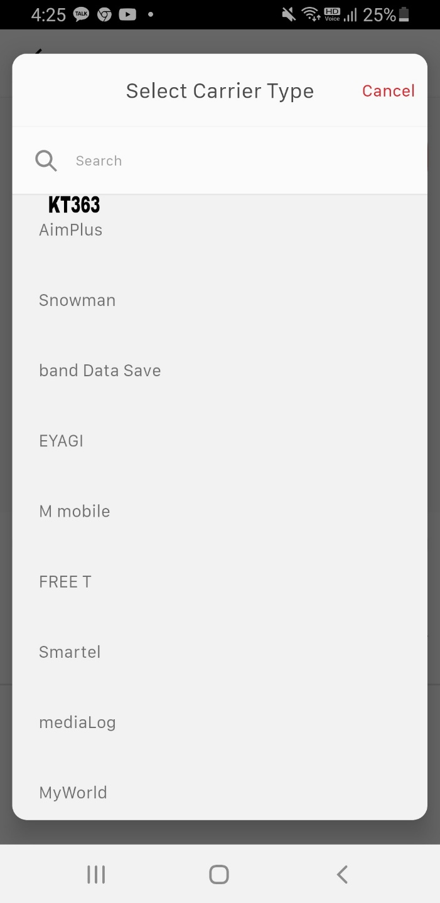

1. If select KT363 then enable to choose plan

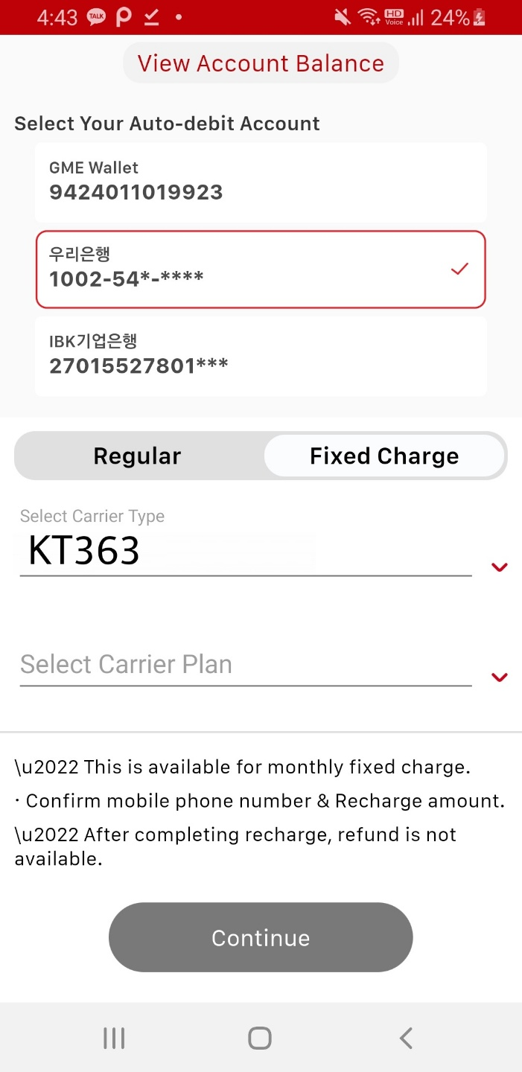

1. After Click Select carrier plan

Select Recharge Type

36,300/30 Days

Voice & SMS (11,000)

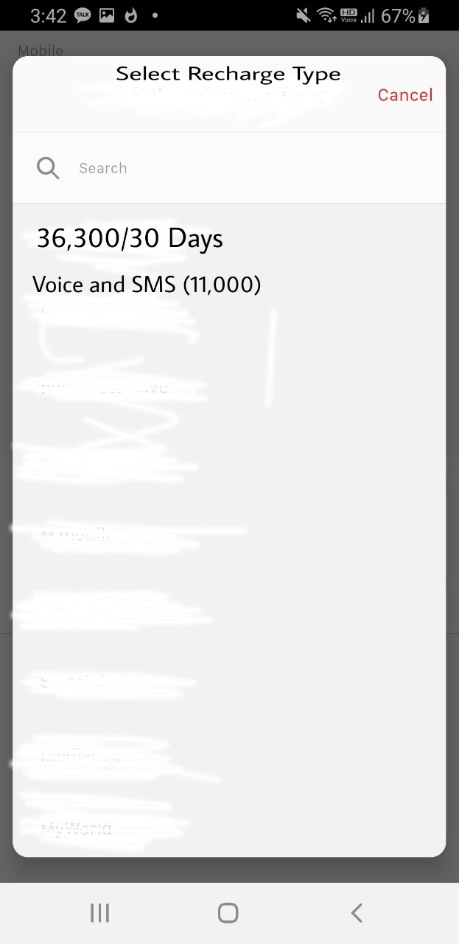

1. After click 36,300/30 Days

Select Recharge Type: KT363

Select Recharge Plan: 36,300/30 Days

Detail

Mobile Phone:       customer number

Charge Type:          KT363/30 Days (36,300)

Data:                        3GB+5mbps

Voice:                      11,000 KRW free balance

SMS:                        11,000 KRW free balance

Payment Amount:  ₩36,300

This is available for monthly fixed charge.

Confirm mobile phone number & recharge amount.

After completing recharge, refund is not available.

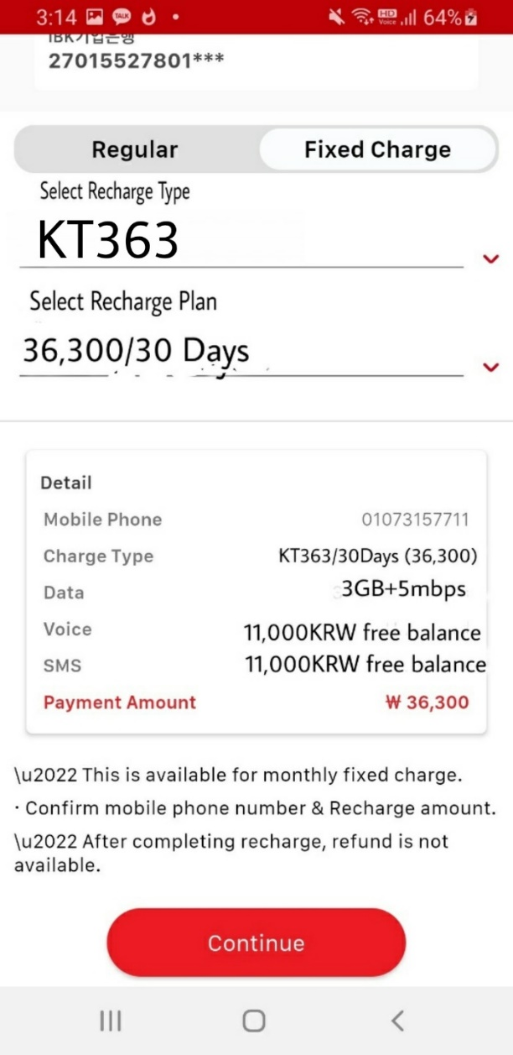

1. After select Voice & SMS (11,000)

Mobile Phone:       Customer number

Charge Type:          Voice & SMS (11,000)

Payment Amount: ₩11,000

This is available for talk time & SMS charge.

Confirm mobile phone number & recharge amount.

After completing recharge, refund is not available.

